The Quarrel

RTC
"I quarrelled with my brother I don't know what about, one thing led to another And somehow we fell out.

1. Write any one quality of the speaker.

2. One thing led to another is related to science. How?

3. And somehow we fell out. Explain.

4. The rhyming scheme of the poem is_____.

5. Replace the phrase 'fell out'.
SAQS
1. Write your experience of a quarrel with your sibling.
2. Find out the irony used in the poem.
3. ' The afternoon turned black '. Explain the meaning and poetic device used in the above line.
4. " Oh, come along! We can't go on all night"- use of direct speech in the poem makes it extraordinary. How?
5. What leads to the quarrel and what ends it?
- Why are we sometimes not able to say why we quarrelled?

HOTS
1. Blood is thicker than water. Elucidate.
2. Sweet moments are both sweet and sour. How?
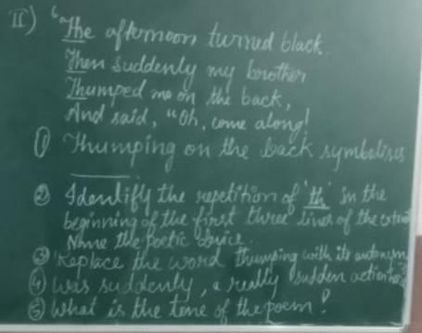
- Most of the quarrels are needless. What is the better way of sorting out problems among ourselves?

